Total Revenue, Total Spend, and Net Profit
This query calculates the most critical financial metrics across your entire dataset in one row. With the help of this query we can find the Over all revenue, Overall Marketing Spent Net Profit and Over all ROAS.

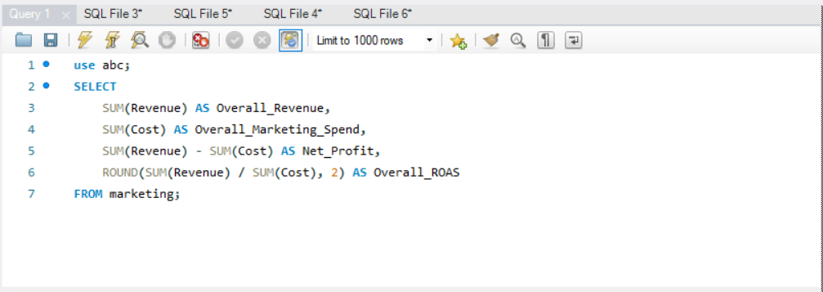
QUERY-;

SOLUTION-;

